Documentation Paper 1

COMPARATIVE PROGRAMMING LANGUAGES [(1229-2865) 12292865](https://elearning.nbcc.ca/d2l/home/140538)

Assignment: Documentation Paper

Student: Larry Loic Kemmo Tejiokem

Instructor: Stephen Johnson

Due: Monday, November 21, 2022

**INTRODUCTION**

The Mountain Game application will test your reflexes by producing 10 rocks at the top the screen, which will gradually fall down to the floor at different speed. The player will have to dodge the rocks as they fall for as long as possible to get a highscore. The highscore will then be stored and displayed so the player can attempt to beat it in the next party.

On building this Mountain Game application, a lot was understood about these 3 different languages (Java, C#, and Python) as well as their respective chosen libraries for this project (libGDX, monogame, pygame). Most of the similarities and differences between these 3 languages are based on syntactical and functional aspects which could be classified as shown below:

**Differences between these Languages**

**File Input / Output**

Based on the aspect of File Input / Output, the main difference between these 3 languages is, Java and Python before applying any basic functionality to the file (write or read), they have to open and close the file when done. On the other hand, C# doesn’t require to any open and close functionality before reading or writing to a file.

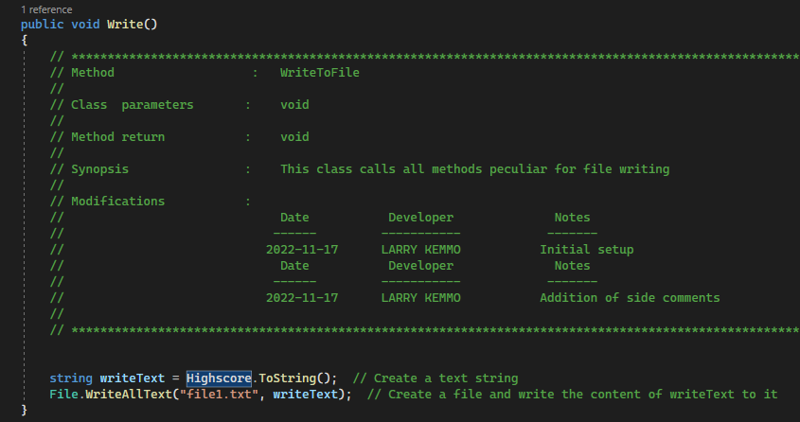

**String Handling**

In Java and C#, it is possible to concatenate with both strings and Integers to form a single message. This is completely different because in python the concatenation must only be of type String, so whenever a message should contain both string and integers, the integers should be passed in a function called str() before the system is capable of reading it.

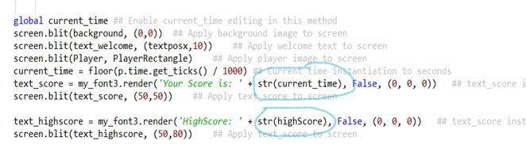

**Parameter passing**

As far as parameter passing is concerned, Java and C# are built in a way that for a method to take in any parameter, its data type has to specified. On the other hand, python doesn’t require any data type specification for parameter passing which might be controversial especially for new learners.

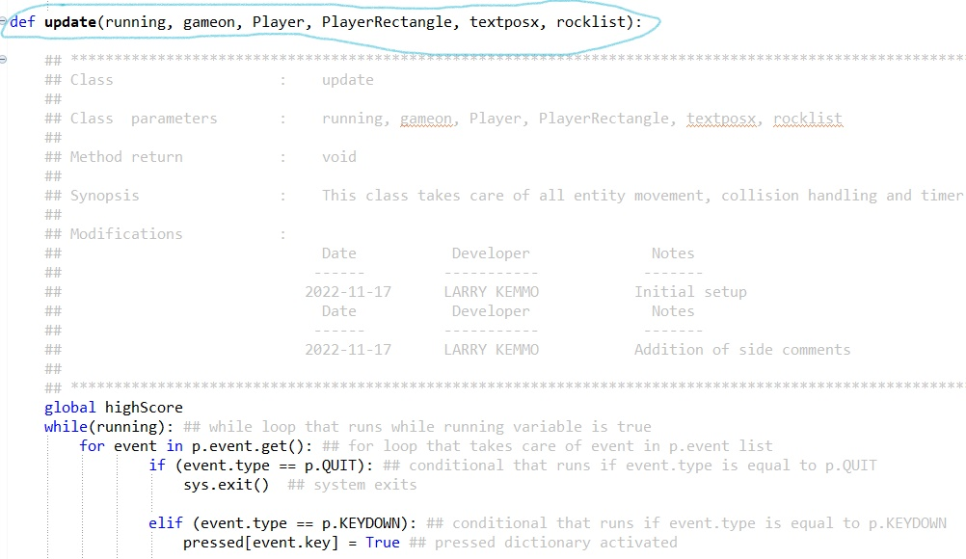

**Object Oriented Programming**

When it comes to Object Oriented Programming, the main difference is that in Java and C#, to be able to create an instance of a class (object), the word “new” is recommended. On the other hand, in Python, no key word is needed.

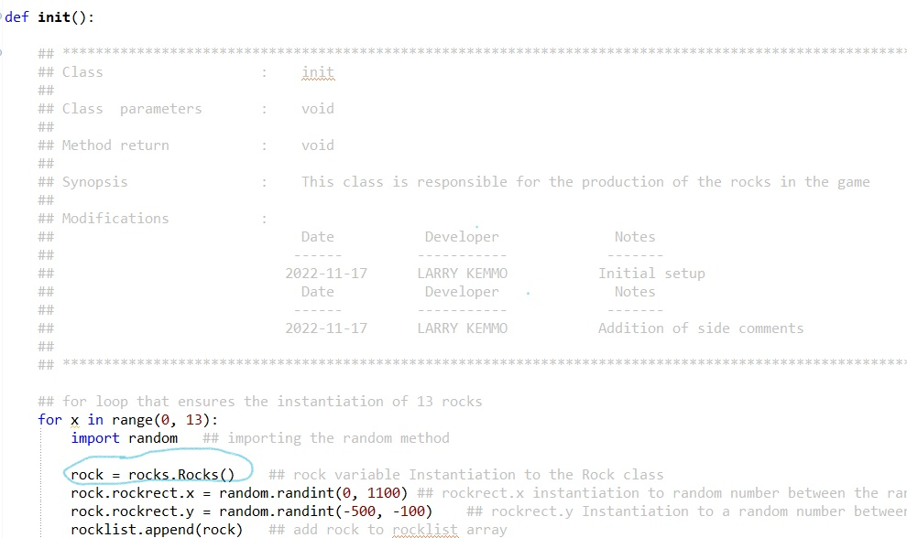

**Exception Handling**

In Java and C# error handling is done using a try – catch with the catch having the code for the exception. This is quite similar to Python’s try – Except only that Python goes a step further to have an else and final condition in case there are multiple exceptions to be taken care of.

**Runtime**

Between these three languages, it was realized while in the testing phase that the quickest language to run the game was Python running the application in less than a second, followed by Java with a runtime of one second, and lastly by C# with a runtime of averagely 5 seconds based on my personal experiments.

**Similarities between these languages**

**File Input / Output**

Despite the difference that exists between these 3 languages as far as file input / output is concerned, there is a similarity they all have which is file creation is done automatically upon writing. This means that there is no need to create a file in the project directory before applying any write or read functionality to it, for it will be created automatically whenever the writing functionality is called upon.

**Pseudo Random generation**

Upon building this game some sort of random generation was necessary, which was great because the process in all of these languages is similar, whereby the Random method is being imported and a method which takes two parameters (Min and Max value) is called and from there a Random number within that range is generated.

**String to integer conversion**

While building this application it was found that String to integer conversion was similar, for it required just a single method in all three languages:  
Java: Integer.parseInt()

C#: Convert.ToInt16()

Python: Int()

**Error Feedback**

In the testing phase it was discovered that all 3 languages gave accurate feedback (Nature, line and class specification) about bugs found in the game.

**Conclusion**

Building this application in three different languages was an interesting and rich challenge, which helped know more about these languages especially their respective libraries (libGDX, pygame, and monogame), appreciating their strengths and pointing out their weaknesses. Nevertheless, in my opinion, python with pygame stood out as the best combination for the development of this application, followed by C# with monogame and Java with libGDX.

**References**

*C# Programming Guide*. (2022, March 31). Microsoft Learn. Retrieved October 3, 2022, from https://learn.microsoft.com/en-us/dotnet/csharp/programming-guide/

*fw_error_www*. (n.d.). Retrieved October 3, 2022, from https://www.java.com/en/

*Welcome to*. (n.d.). Python.org. Retrieved October 3, 2022, from https://www.python.org/doc/